1.Ec2 Instance Creation:
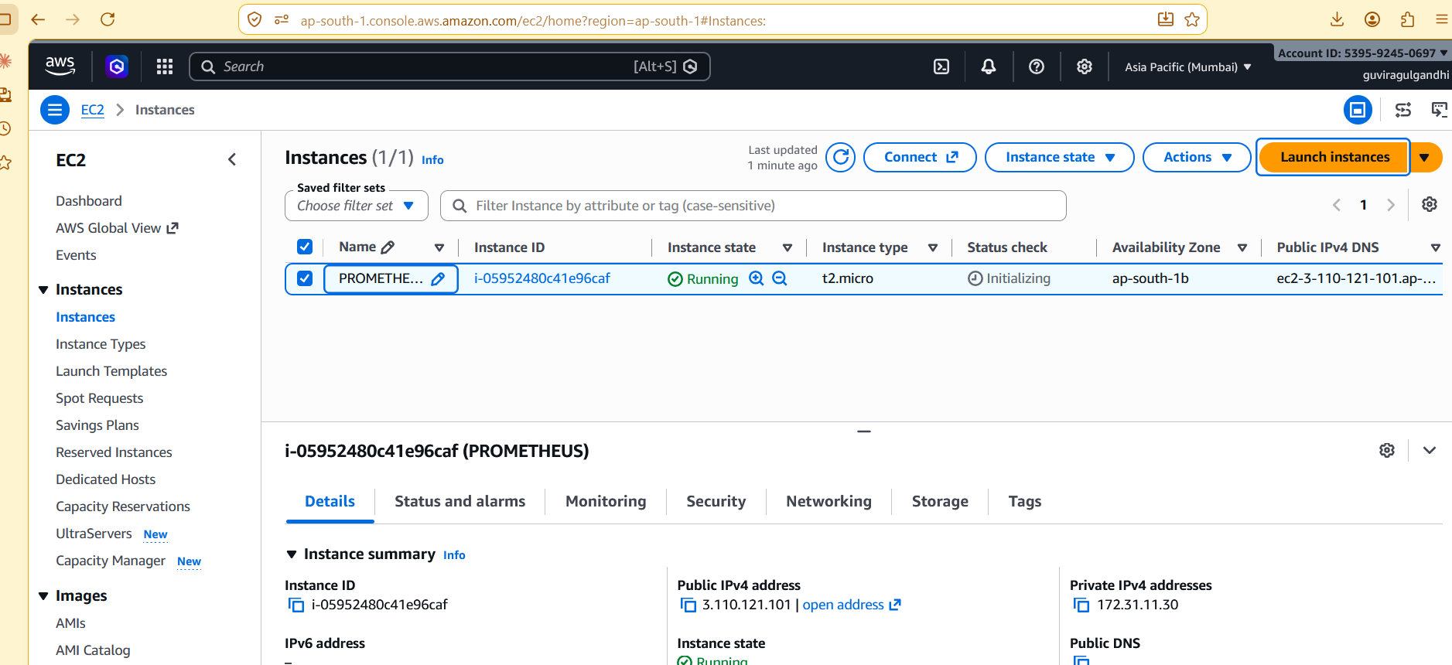
2.Prometheus 3.13.3 Installed in the Ec2 Machine with default port 9090:
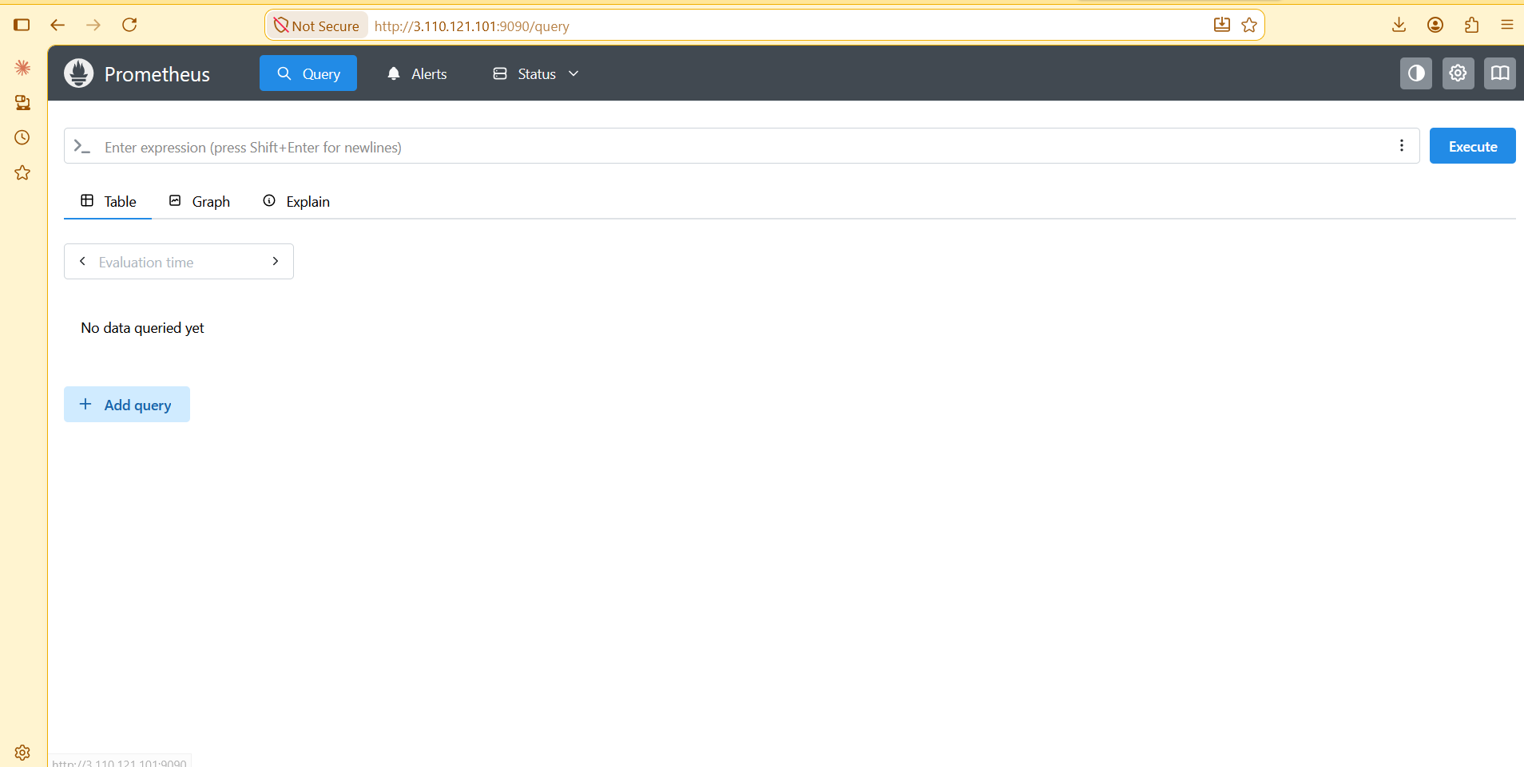
3.Node exporter installed on the target machine for metrics:
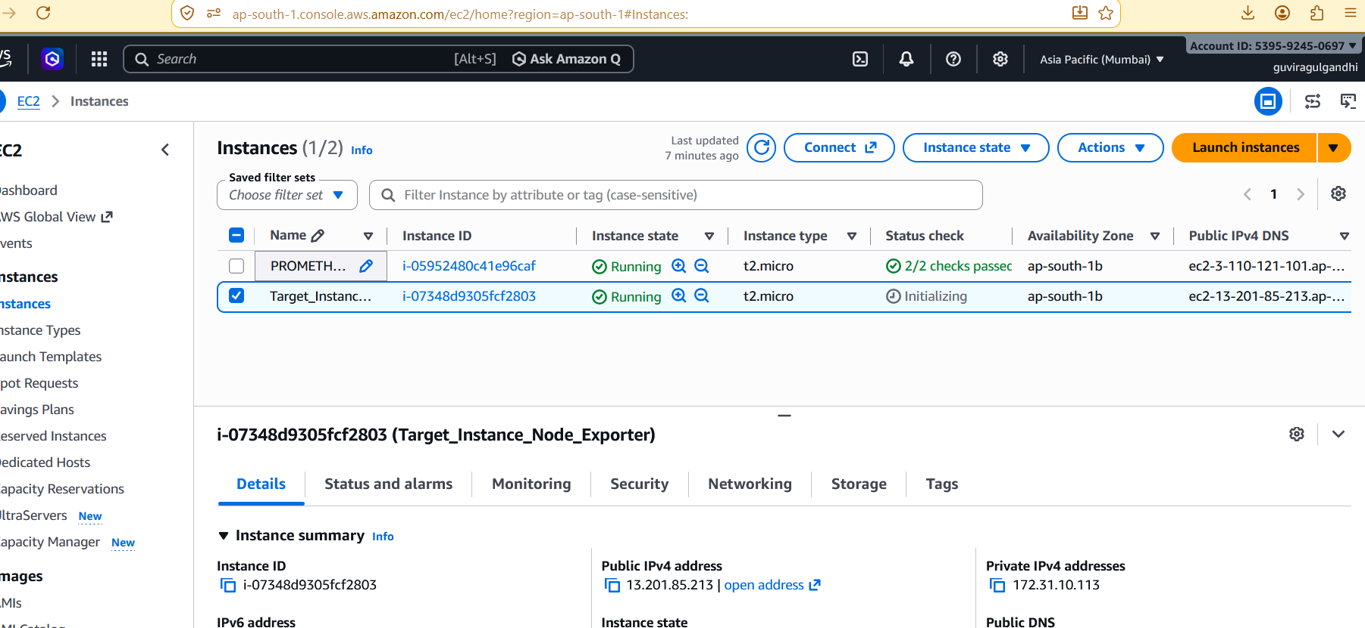
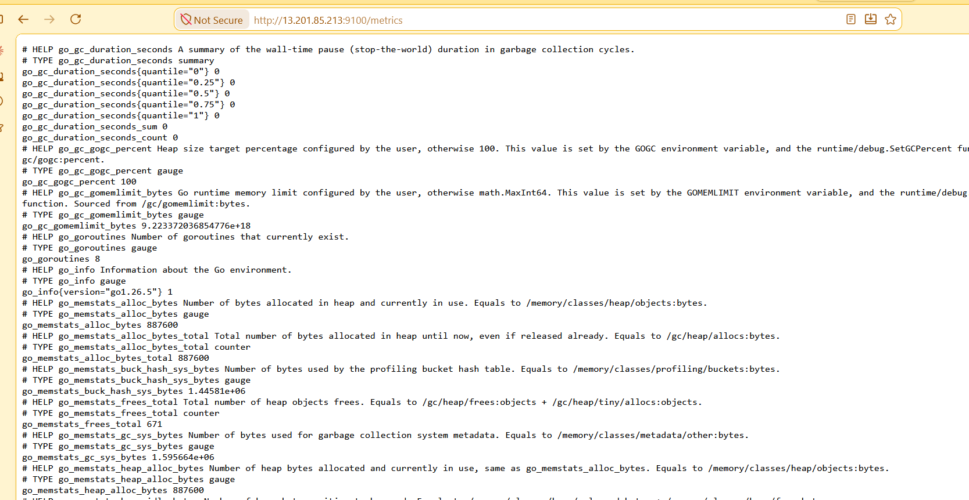
4.Grafana installation to visualise metrics in same Prometheus serve with port 3000:

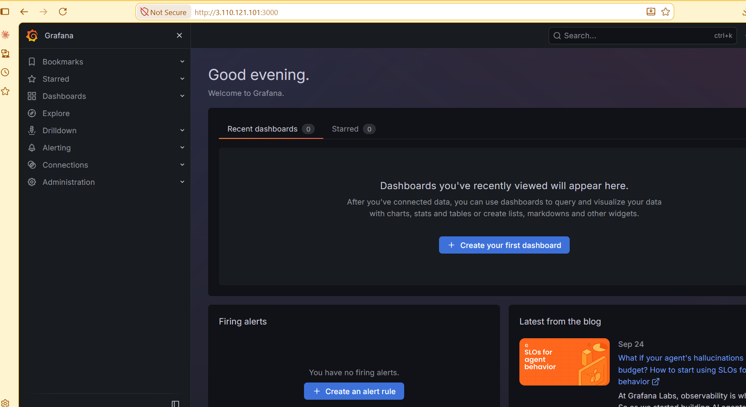
5.Mapping target instance for scraping (pull) from prometheus server:
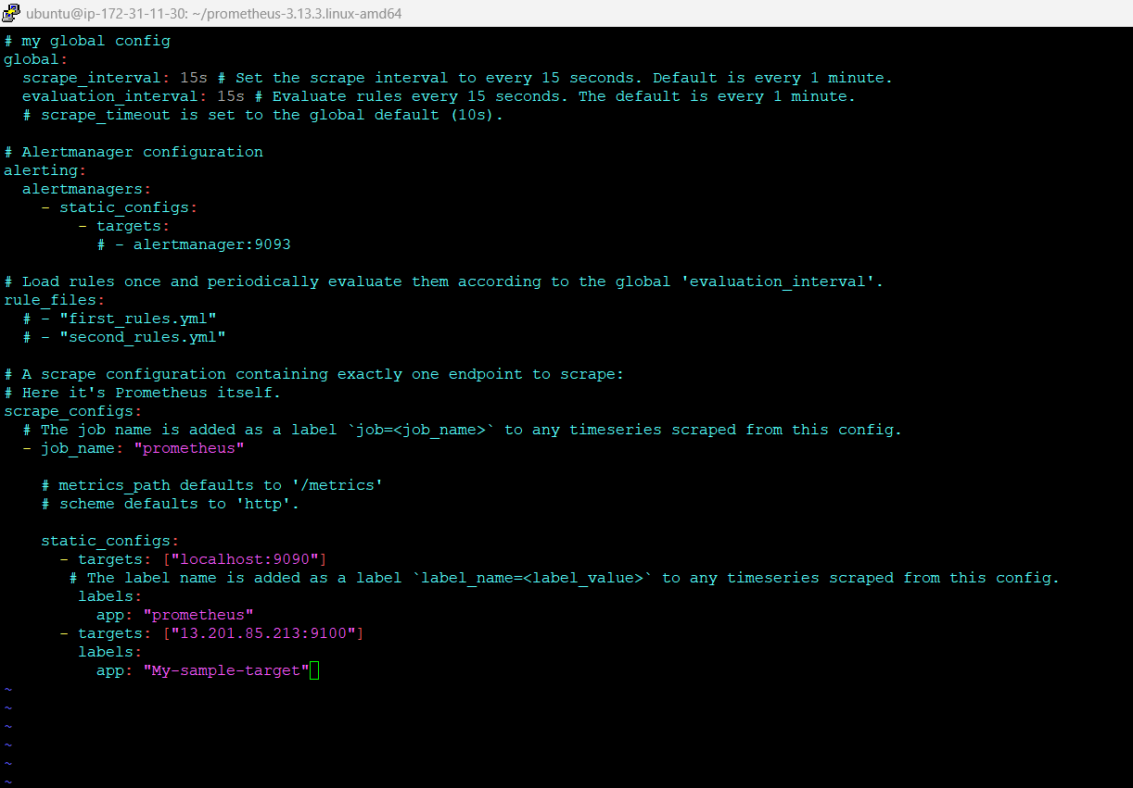
6.Restarting the Prometheus server.
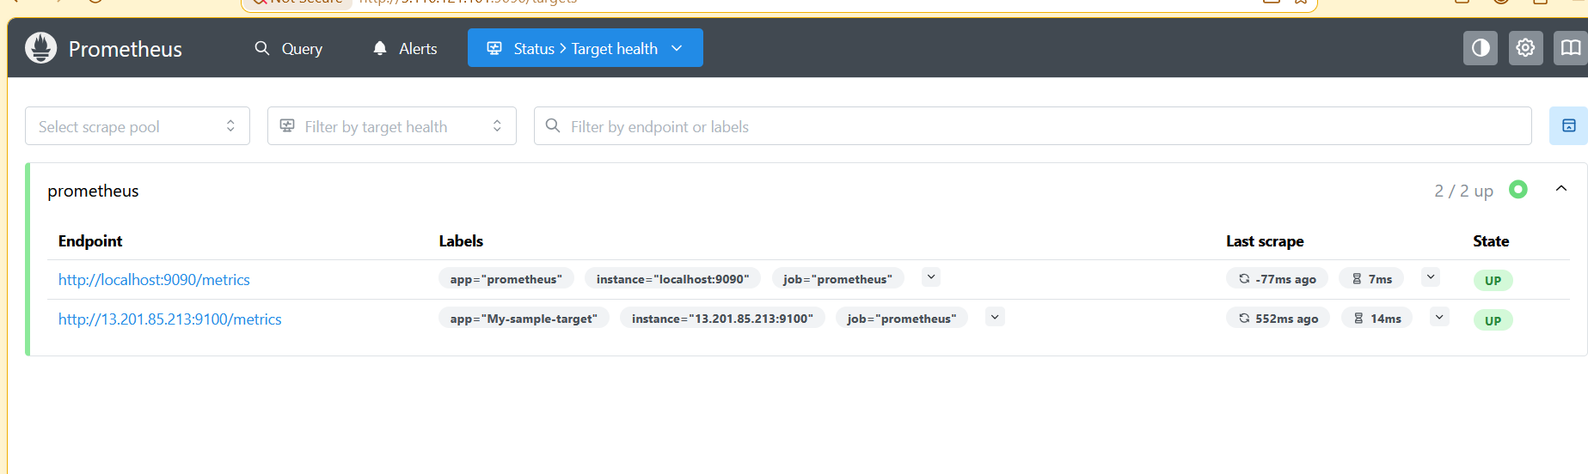
7.Visualizing the metrics from the Grafana by adding data sources and Node exporter(1860):
